**Electronics-I Assignment 1**

Q1: Find the value of Vx in the following given circuit.

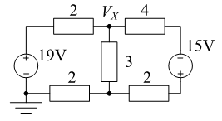

Q2: For the following circuit find the value of voltage at point A using superposition theorem.

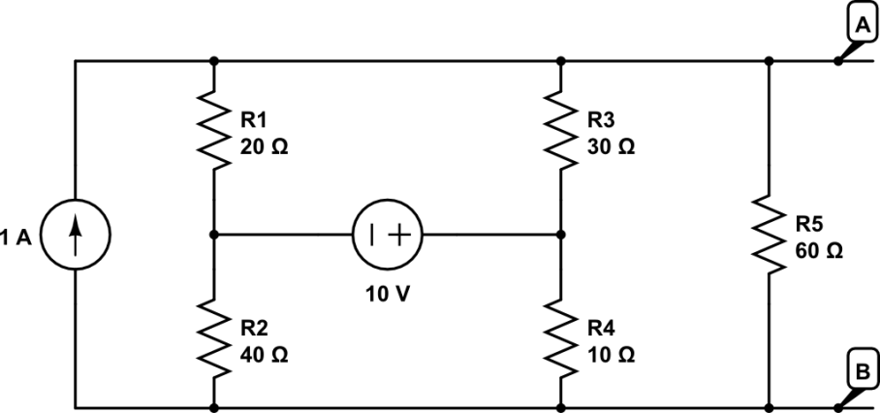

Q3:Find the value of voltage at point V1, V2 and V3, using KCL

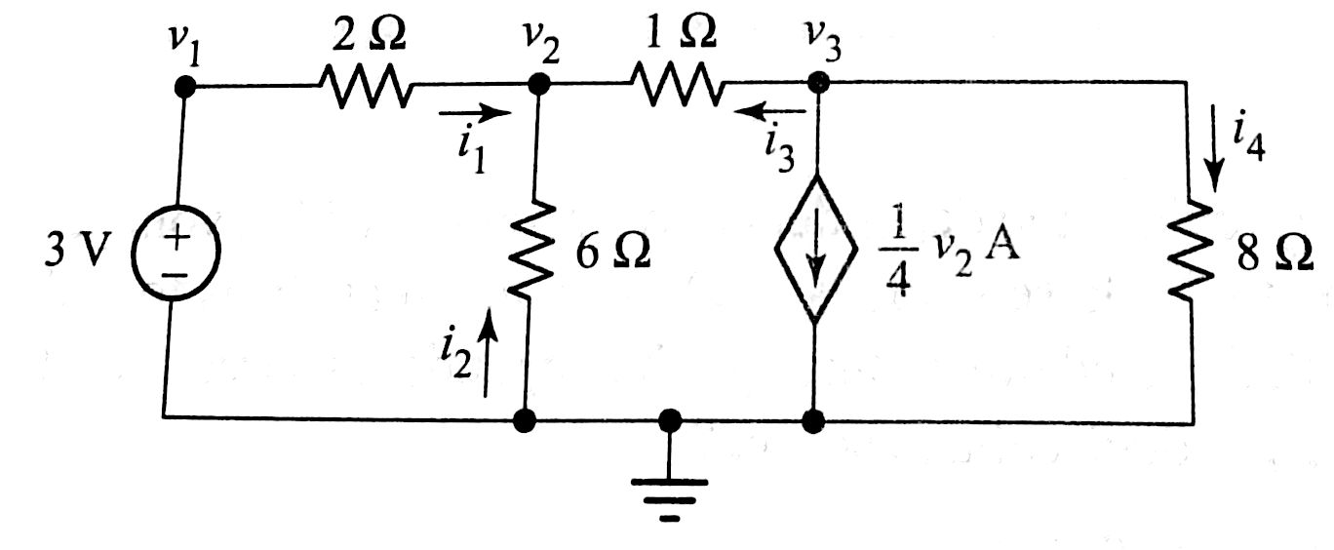

Q4: Consider that Circuit A is a mobile charger circuit and Circuit B is the corresponding mobile phone. What should be the ideal input imprudence of the mobile phone to extract maximum power from the charger unit?

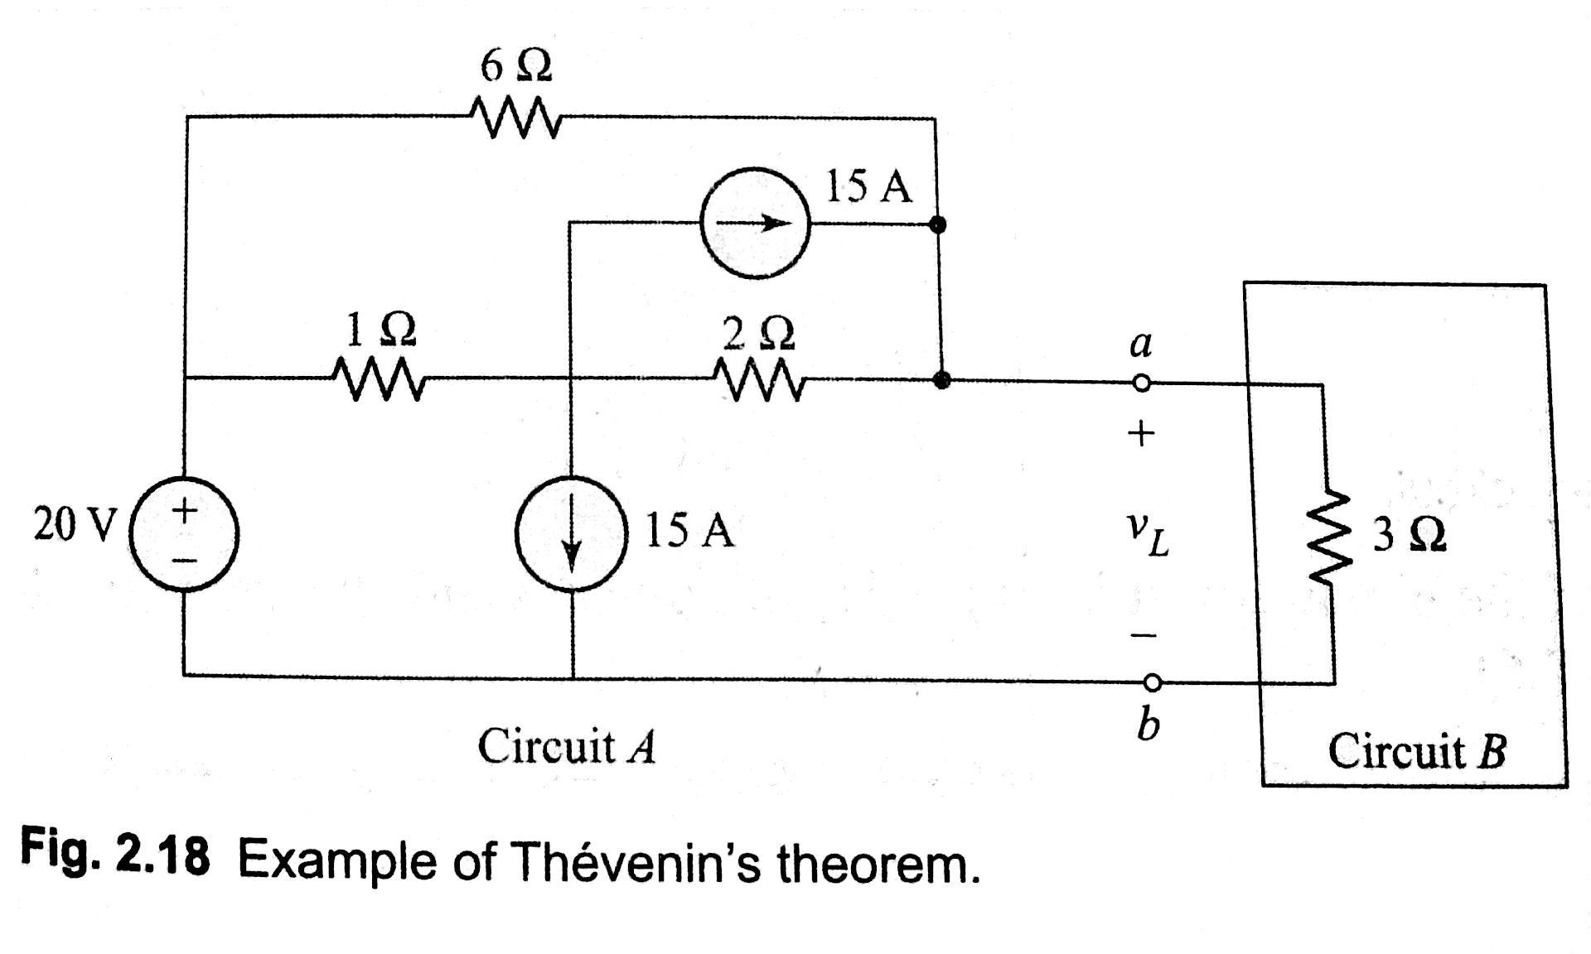

Q5: Find the Norton equivalent of Circuit between open junctions.

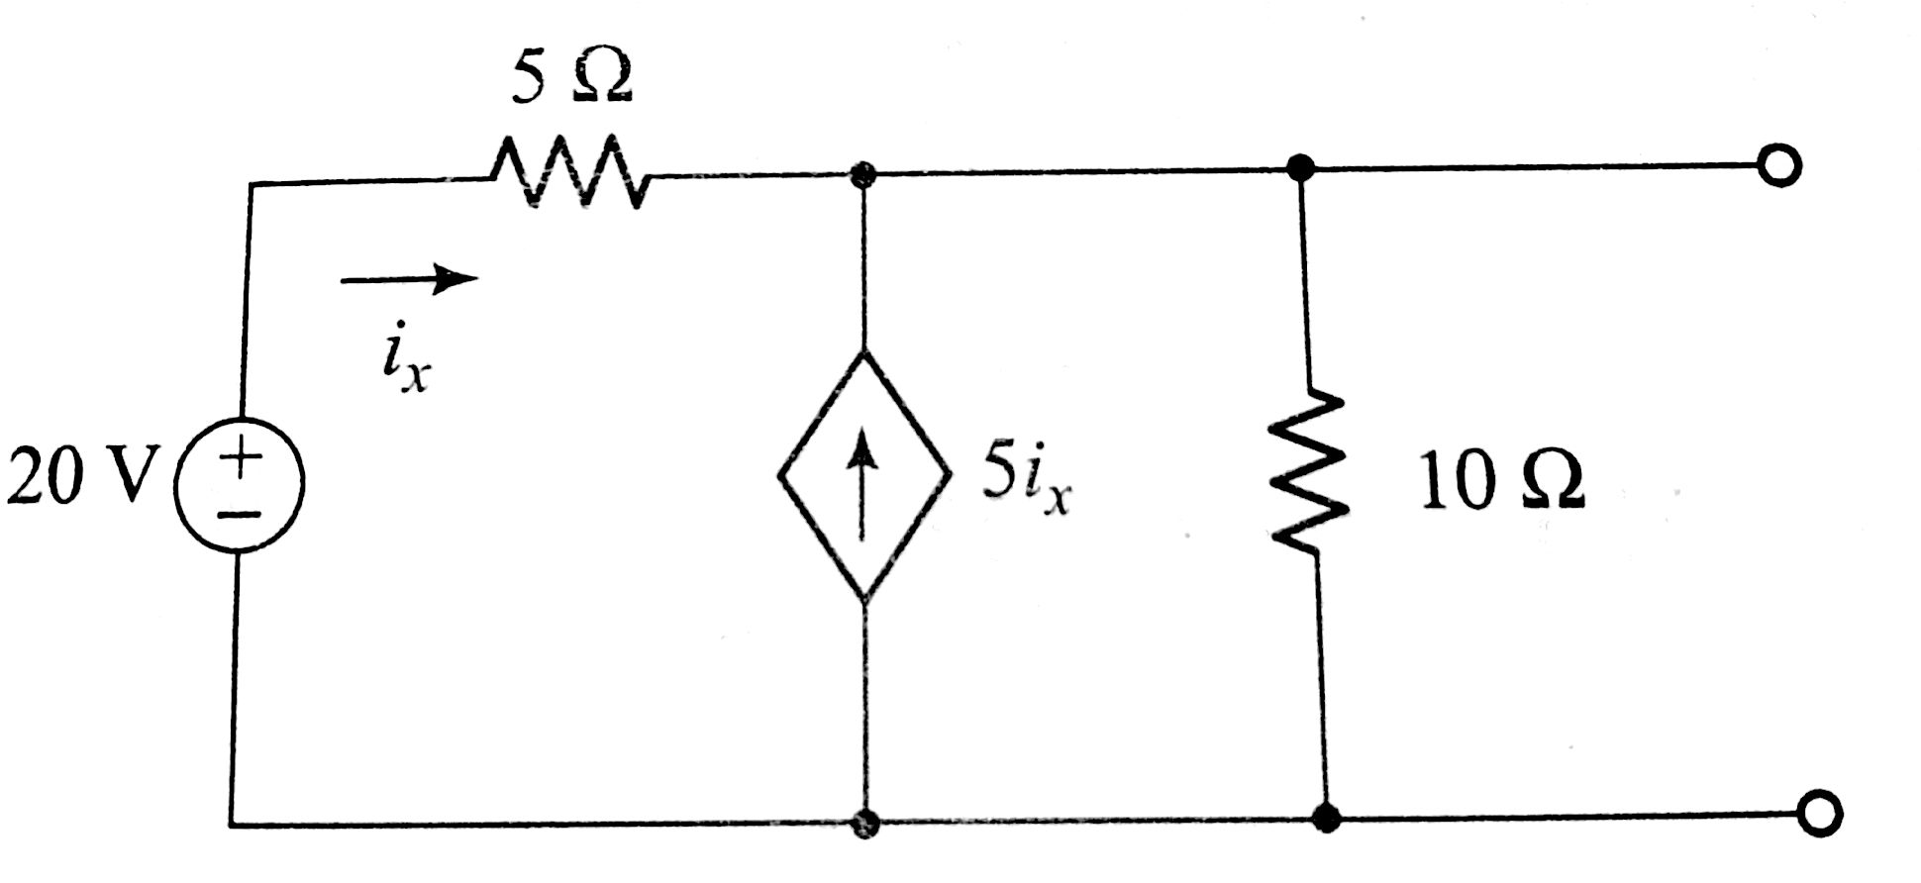

Q6: Find the Thevenin equivalent of Circuit A across points a and b.

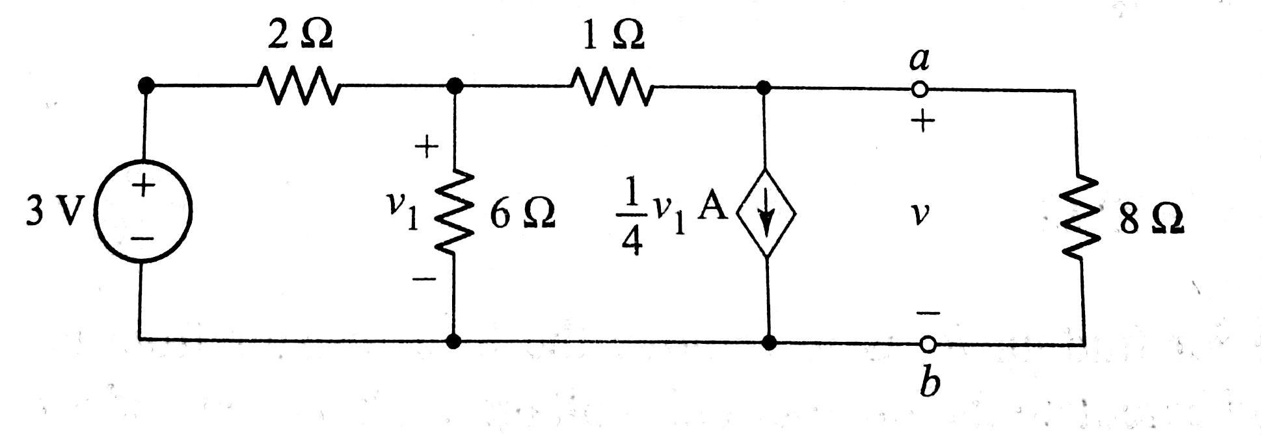

Q7: Find the value of V0 by transforming all the current sources to voltage sources.

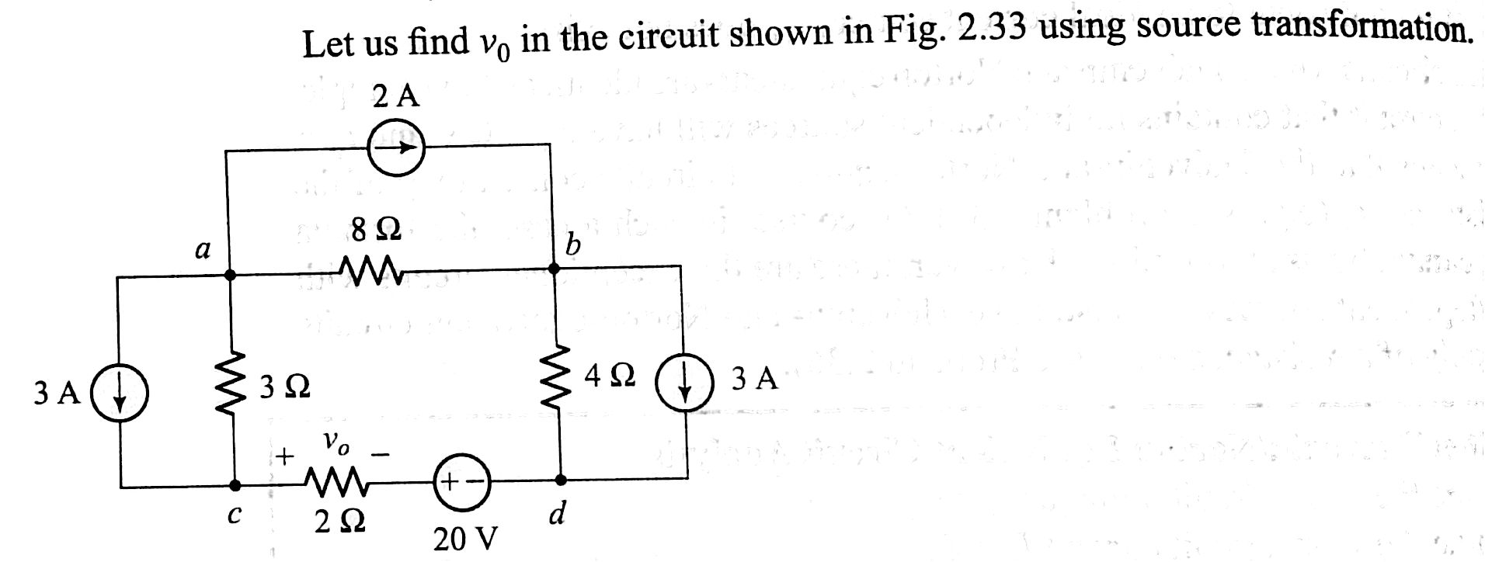

Q8: Clculate the value of V by applying KVL in the circuit below.

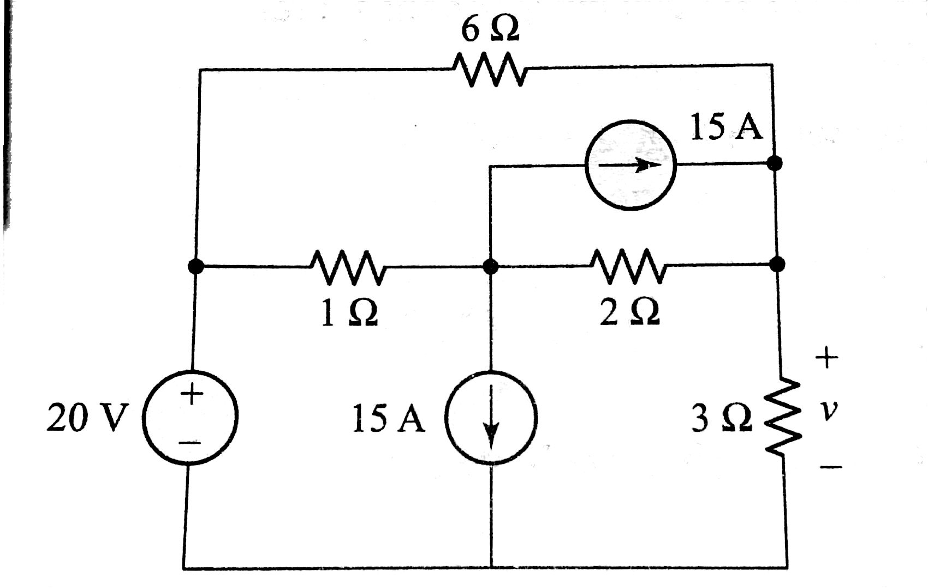

Q9: Find the Thevenin and Norton equivalent of the circuit given blow.

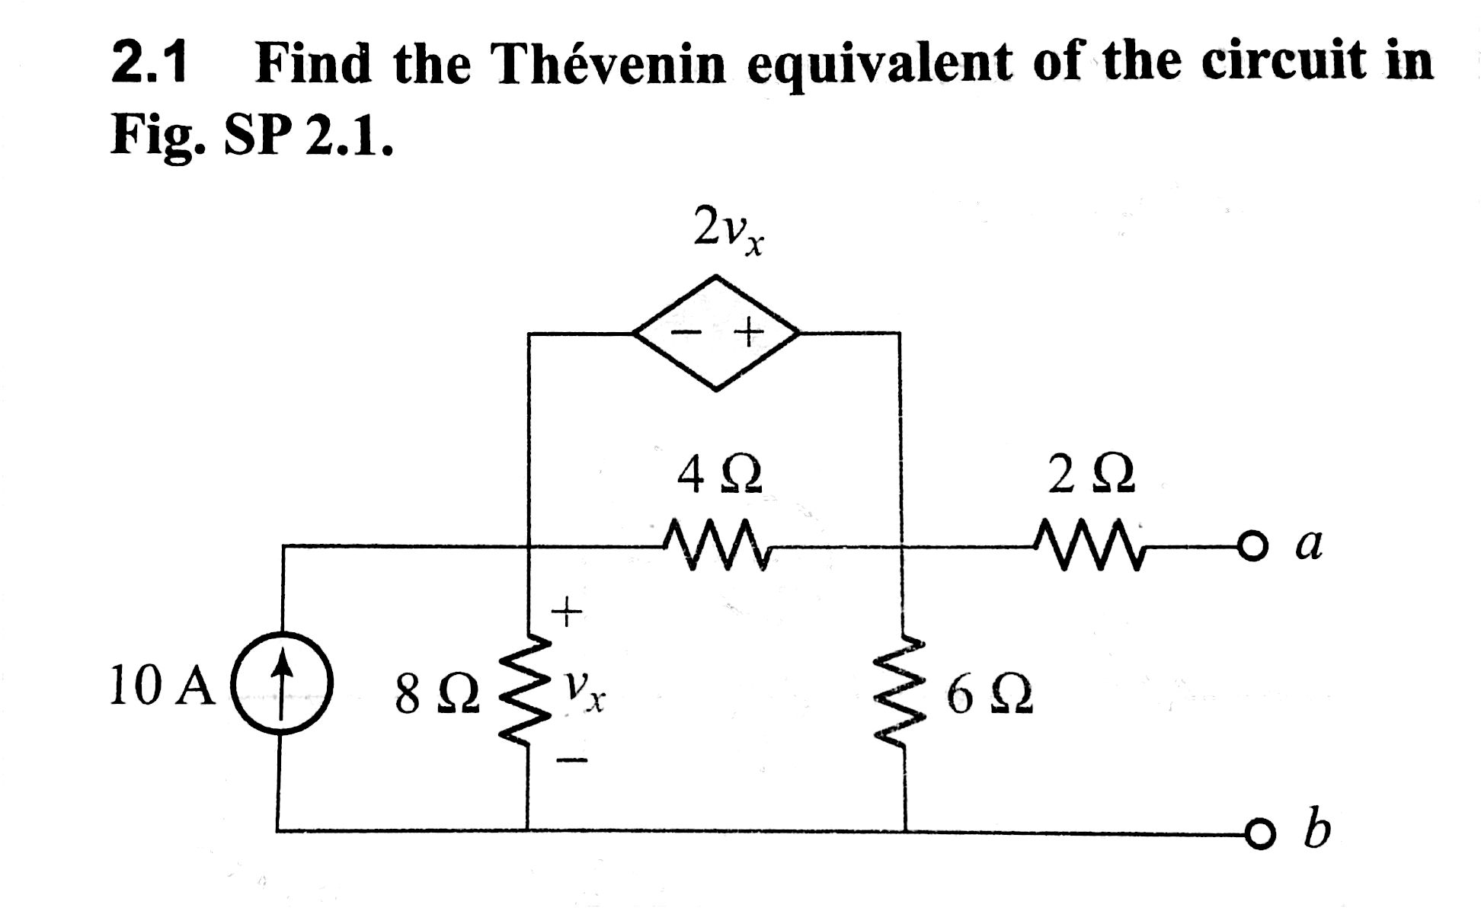

Q10:

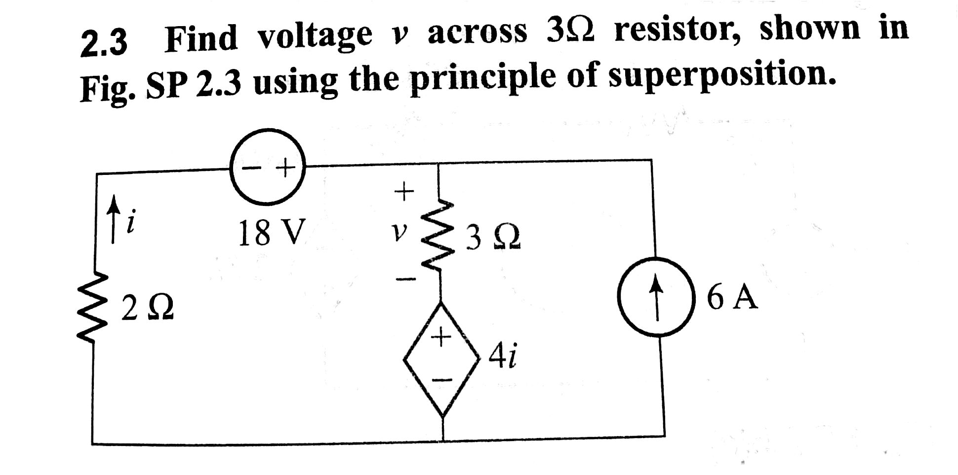

Q11:

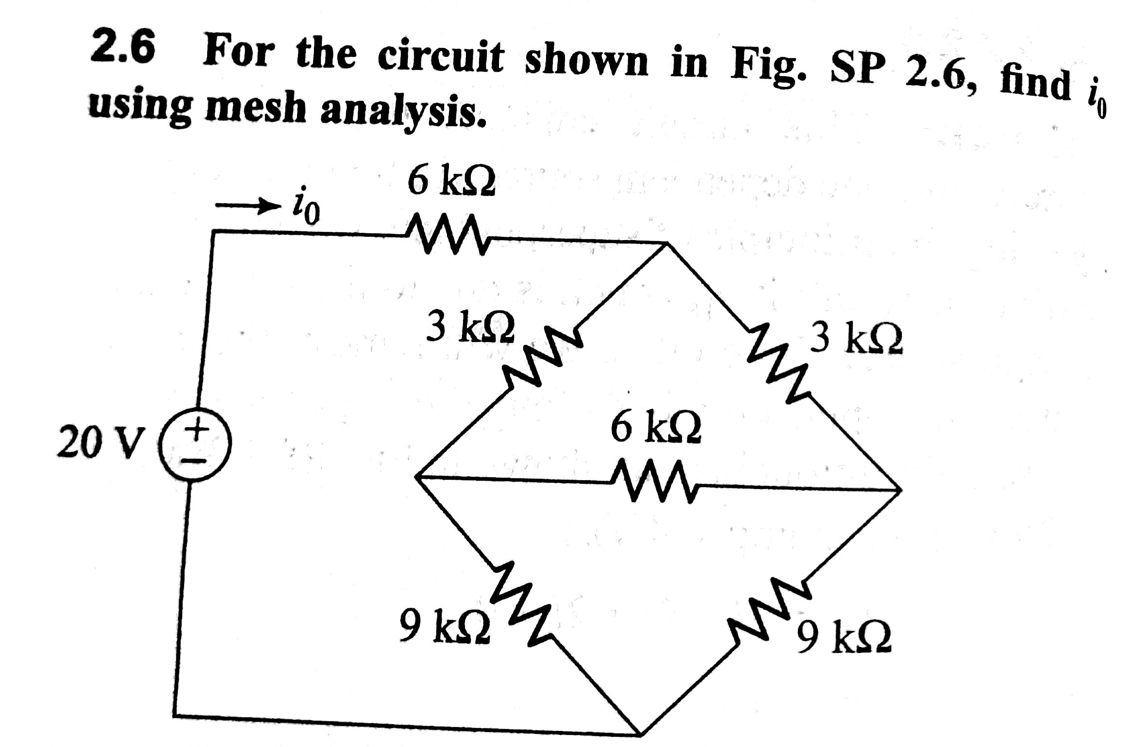

Q12:

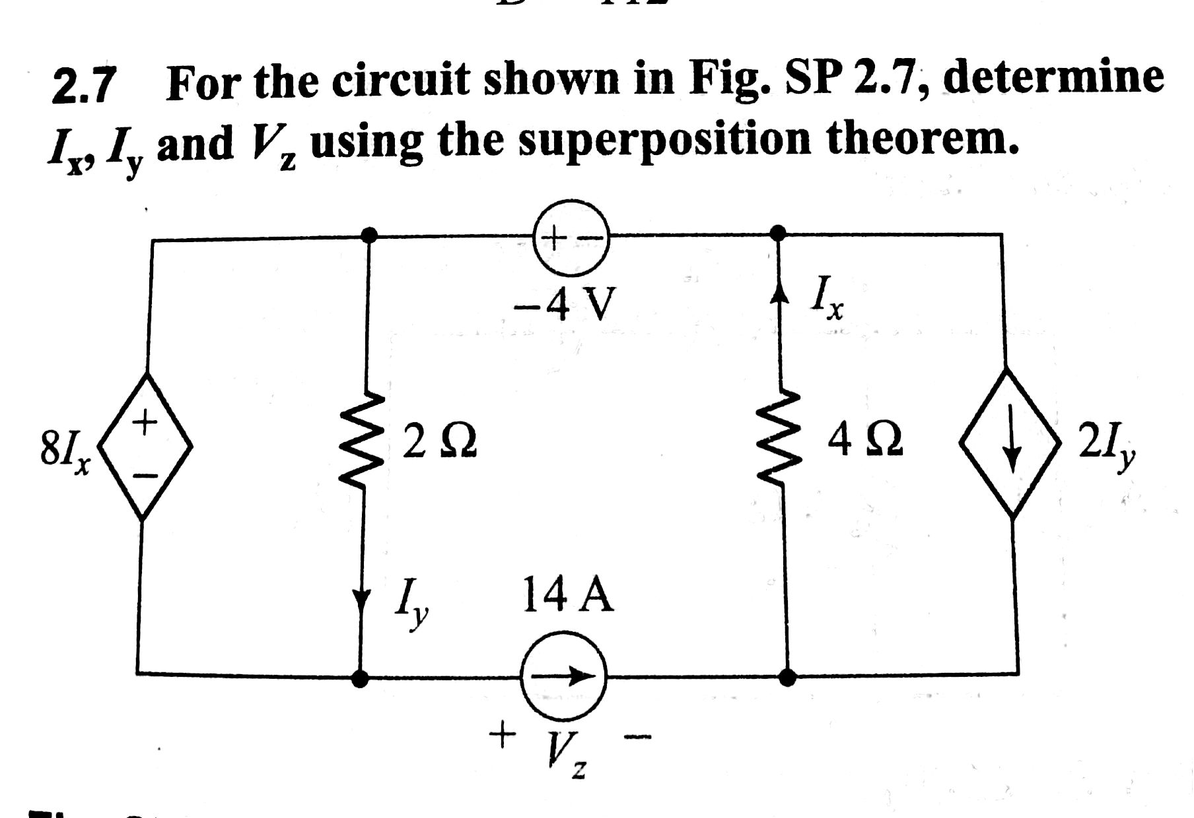

|  |  |
| --- | --- |
| **Q13. Using KVL calculate I and V in the circuit of Fig. 1.** | **Q14. Calculate V1 and V2 in the circuit shown below**    ***Hint : use both KVL and KCL to solve the circuit*** |
| **Q15. Find the values of *I1* and *I2*.**    ***Hint: Use current division rules.*** | **Q16. Find the value of voltage *V1* and current *I1 in the circuit given below*.** |
| **Q17. Find the values of mesh currents *I1* and *I2*.** | **Q18. Find the values of *I1*, *I2* and voltage *Vx*.** |
| **Q19. Solve the Question 14,15, 17 and 18 using superposition theorem and verify whether your answers match with previous answer.** | |
| **Q20. Find the Thevenin’s equivalent circuit at terminals *a* and *b* of the circuit shown below.** | |
| **Q21. What is the Norton’s equivalent circuit of the circuit shown below?** | |